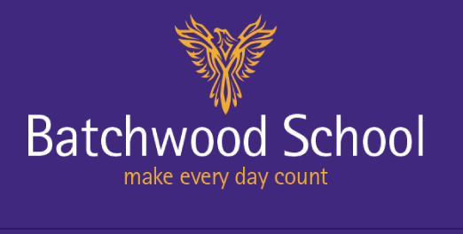
ABC
About Batchwood Careers Batchwood Careers Newsletter

Careers contact: Sarah Slater careers@batchwood.herts.sch.uk April 2019

News of improvements to the careers department at Batchwood School.
The Careers tab (under Learning) on the Batchwood School website is being updated
Log in to see the latest career news, and helpful links
Careers Corner
An area of the school is being designated as a Careers area where students may browse a college prospectus, look at apprenticeships, job specifications

As the KS4 students prepare for the next stage,
Youth Connexions will be in school offering
personal support in choosing their college options,
helping them to visit colleges and fill in the
application forms.

